Question 8 [6 Points]
Create a shell script bg_move.sh that accepts a directory path.
• Move each file in the directory into a subdirectory named backup/
• Perform each move operation in the background
• Display the PID of each background process
• Wait for all background processes to finishUse &, wait, $$, and $! variables.
---
Script:
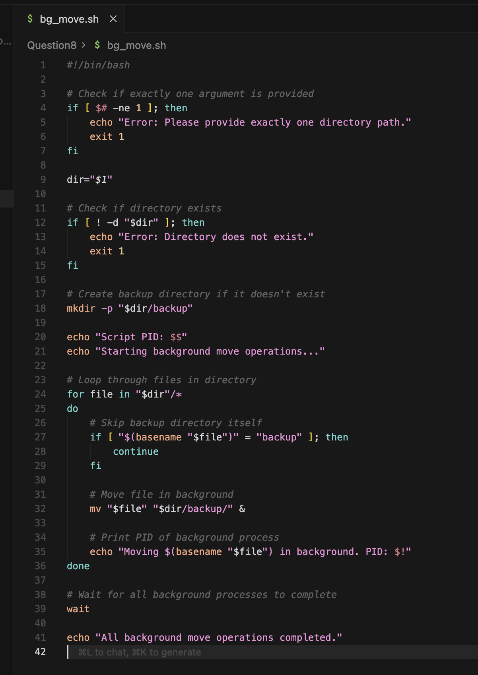
Explanation :
The script moves files into a backup directory using background processes, prints the PID of each job using $!, and synchronizes execution using wait
Output: